# Movie Franchises: Impact on Average Movie Ratings

In the process of testing the recommendation system I built (see accompanying documentation), I provided the model with ratings for some of the movies I had seen. It was during this process that I noticed how I tend to rate movies from franchises differently than stand-alone films. This got me curious to see whether the same could be said for other users, and if so, what might motivate such thinking?

To further explore the phenomenon, we can look at the short term (6 month) average rating for two of the most popular film franchises of the past decade, Harry Potter and Phase 1 of the Marvel Cinematic Universe (MCU). These also happen to be good examples to look at because Harry Potter, as a film franchise, tends to focus on the same characters for all 8 of its movies. Meanwhile, the MCU is largely disjointed with most of the movies focusing solely on one superhero. As such, it can be expected that the MCU movies will behave more similarly to stand-alone films up until the final film of Phase 1, ‘The Avengers’, in which all the characters are brought together.

## Common Trends

Both of these franchises have a huge and highly engaged fan base, Harry Potter more so than the MCU. These avid patrons go to see new movies as close to the opening night as possible. This means that the initial average rating following the movie’s release tends to be inflated because the majority of ratings will be from fans of the source content. In time, the movie’s elevated average tends to drop as people who aren’t as enthusiastic about the film submit their ratings.

## Example 1: Harry Potter

As we chronologically go through the release of each installment in this franchise, we almost always see a corresponding positive response in the six-month average for the movie’s predecessors. Again, there could be a few reasons for this:

1. The excitement and anticipation leading up to the release of a new installment can positively affect the rater’s opinion.
2. Having witnessed the next chapter of the story, a rater could end up happily reminiscing over the enjoyment of prior installments, again positively affecting their opinion.

Months after the release of the final film, the whole Harry Potter film franchise shows an increased short-term average. These rating increases begin around November 2011 and happen to coincide with the release of the entire film collection as a box set. Other announcements regarding the J.K. Rowling’s wizarding world (Harry Potter and the Cursed Child, movie adaptation of Fantastic Beasts) have likely helped sustain the higher six-month average over time.

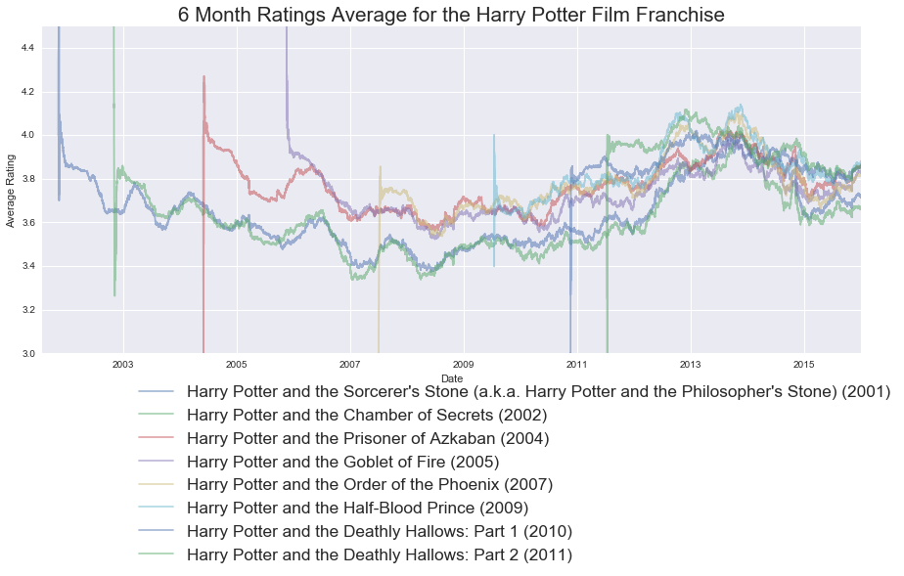

## Example 2: Marvel Cinematic Universe

While going through the MCU movies chronologically, there is little to no impact on the short term rating averages for most of the movies in this franchise. This behaviour is what one would expect from a stand-alone film. However, this trend changes with the release of ‘The Avengers’. Since its release, all five of its predecessors have a noticeable increase in their short term averages. This may be attributed to:

1. ‘The Avengers’ being such a noteworthy movie that it left a lasting positive impression of all the characters and therefore improved their respective movie ratings.
2. ‘The Avengers’ commercial success attracted new viewers to the franchise who went back to see the older movies, enjoyed them, and then proceeded to rate them highly.

